# Assignment-1 Software Installation Prashanth.S(19MID0020) **Installation of Apache Netbeans**

Apache Netbeans 14 🡪 <https://netbeans.apache.org>

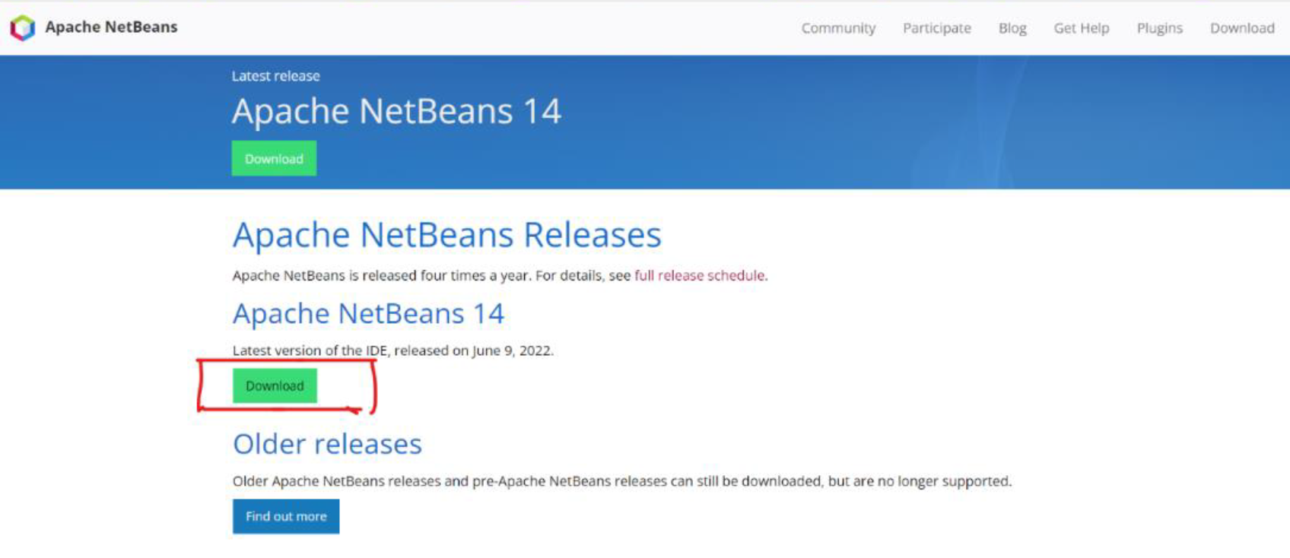

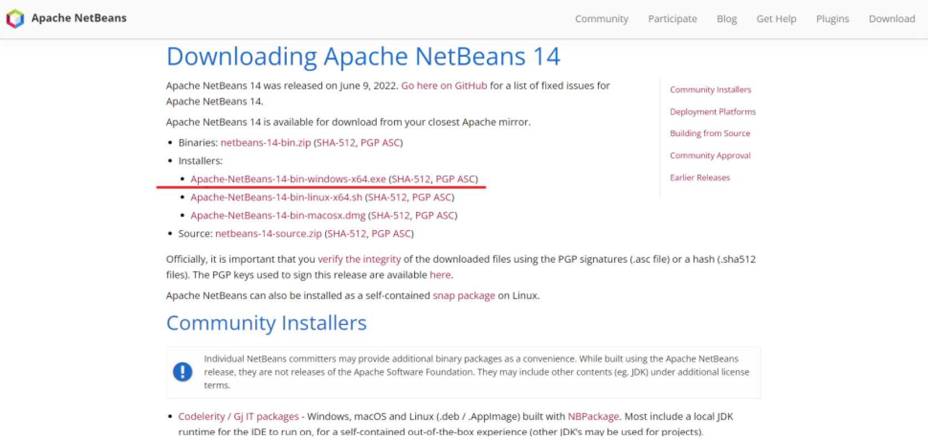

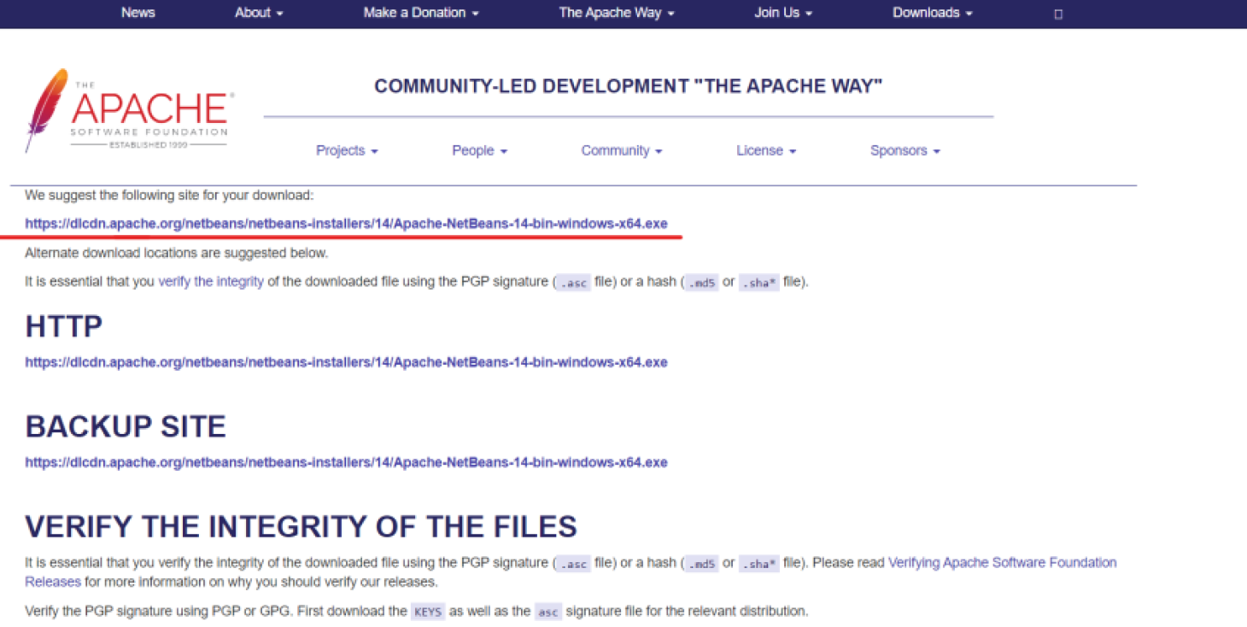

# **Installation of MySQL Workbench**

MYSQL workbench 🡪 <https://dev.mysql.com/downloads/workbench/>

MYSQL Server 🡪 <https://dev.mysql.com/downloads/mysql/>  
MySQL connector 🡪 <https://dev.mysql.com/downloads/connector/j/>

MySQL in terminal

/usr/local/mysql/bin/mysql -u root -p (or)

mysql --user=root -p  
then type your password

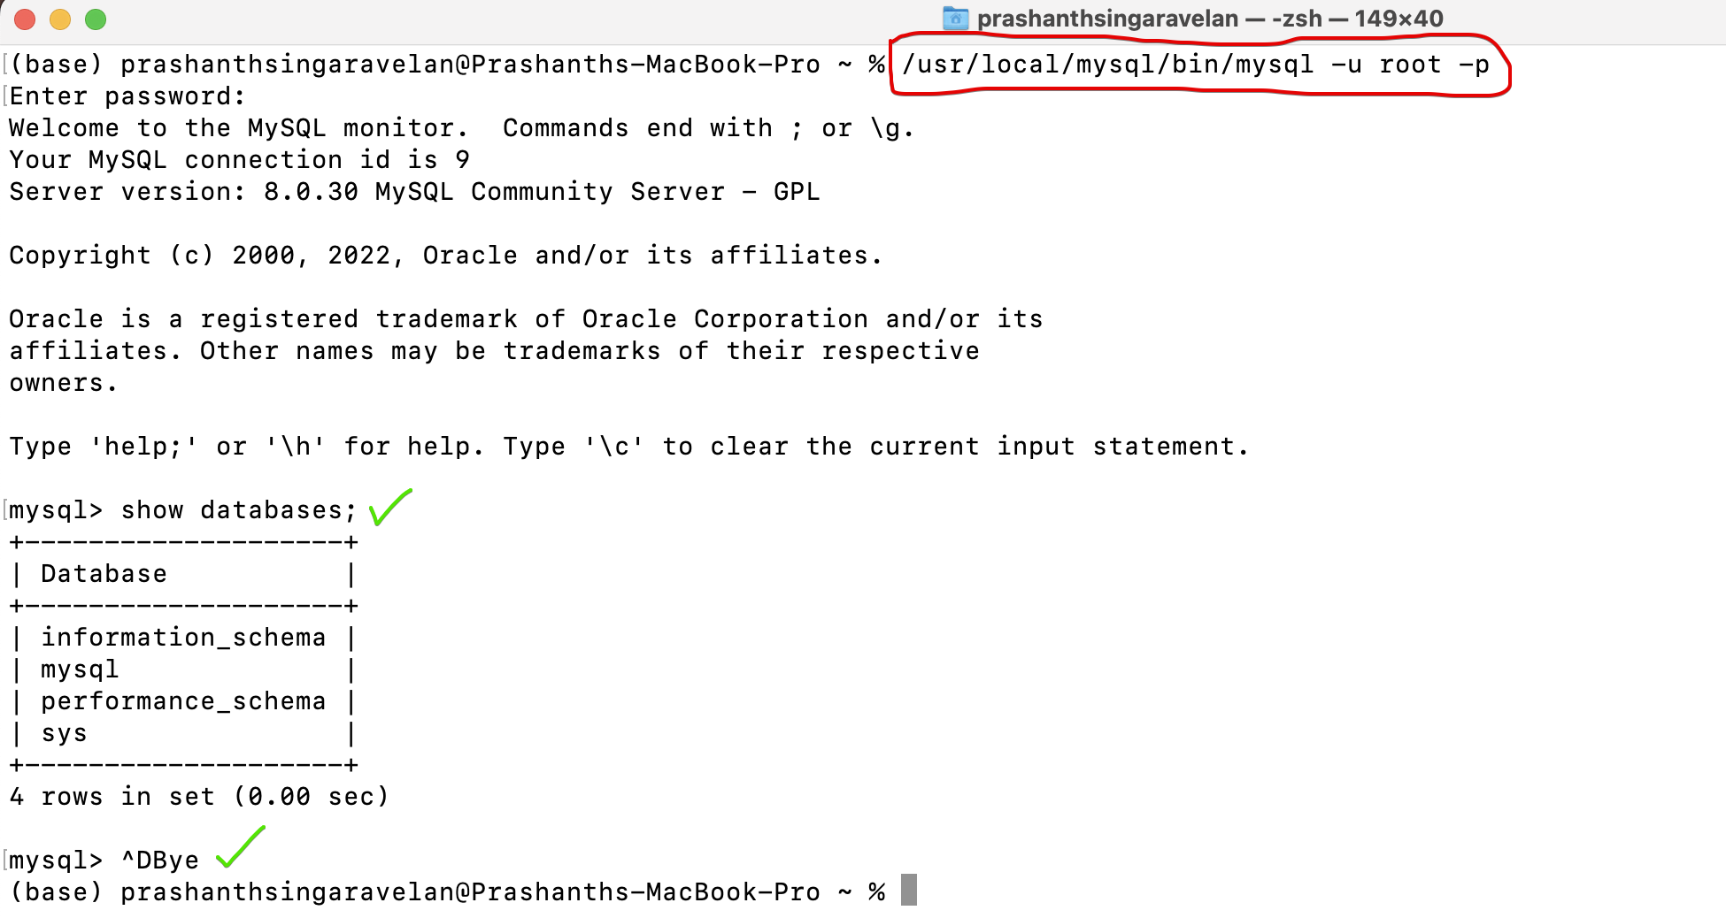

To clear MySQL console 🡪 \! clear

Creating a sample data-base along with tables before adding the connector  
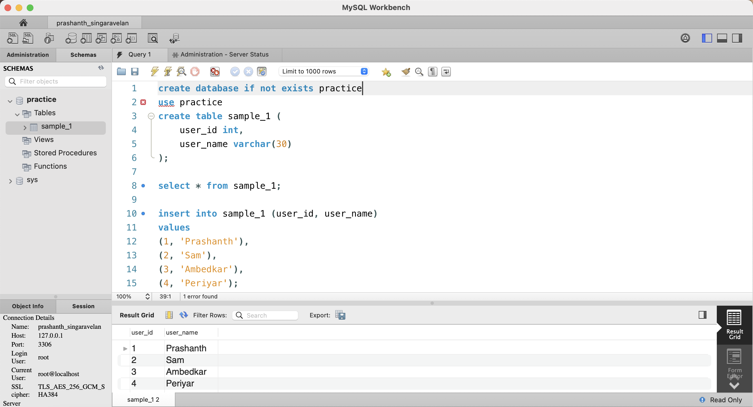

Make the sure that MySQL server is on.

# **Step-1**

Add connector to Netbeans

Connecting MySQL connector with Apache Netbeans  
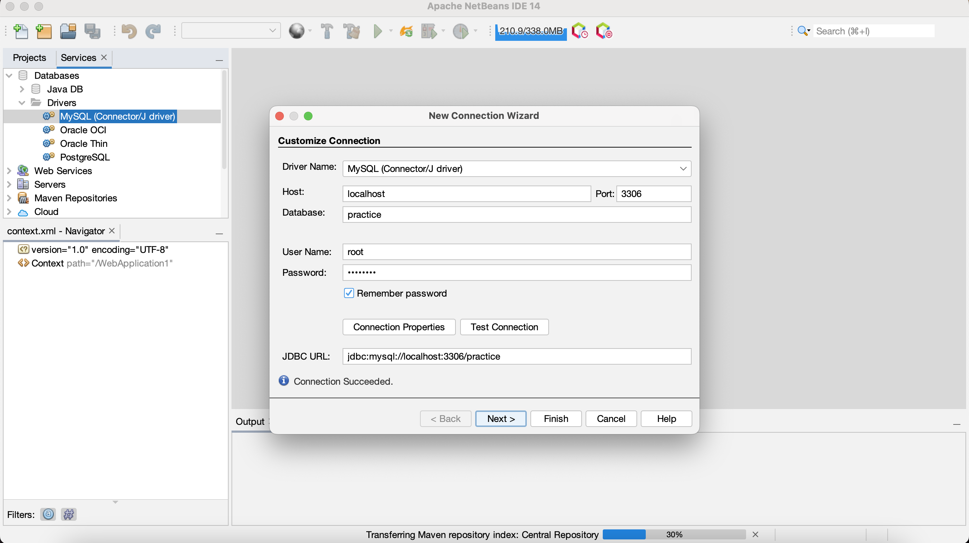

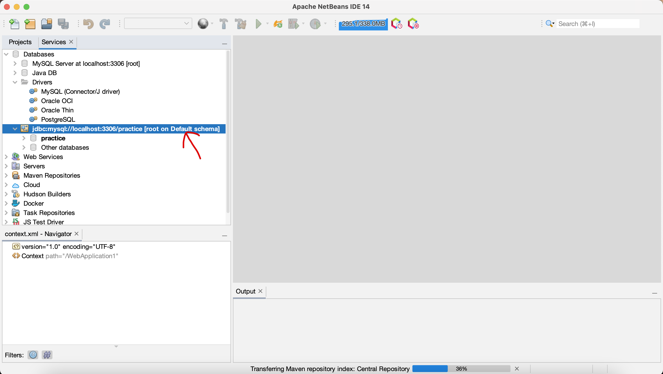

Connector added successfully.

Creating a table along with tables before adding the connector  
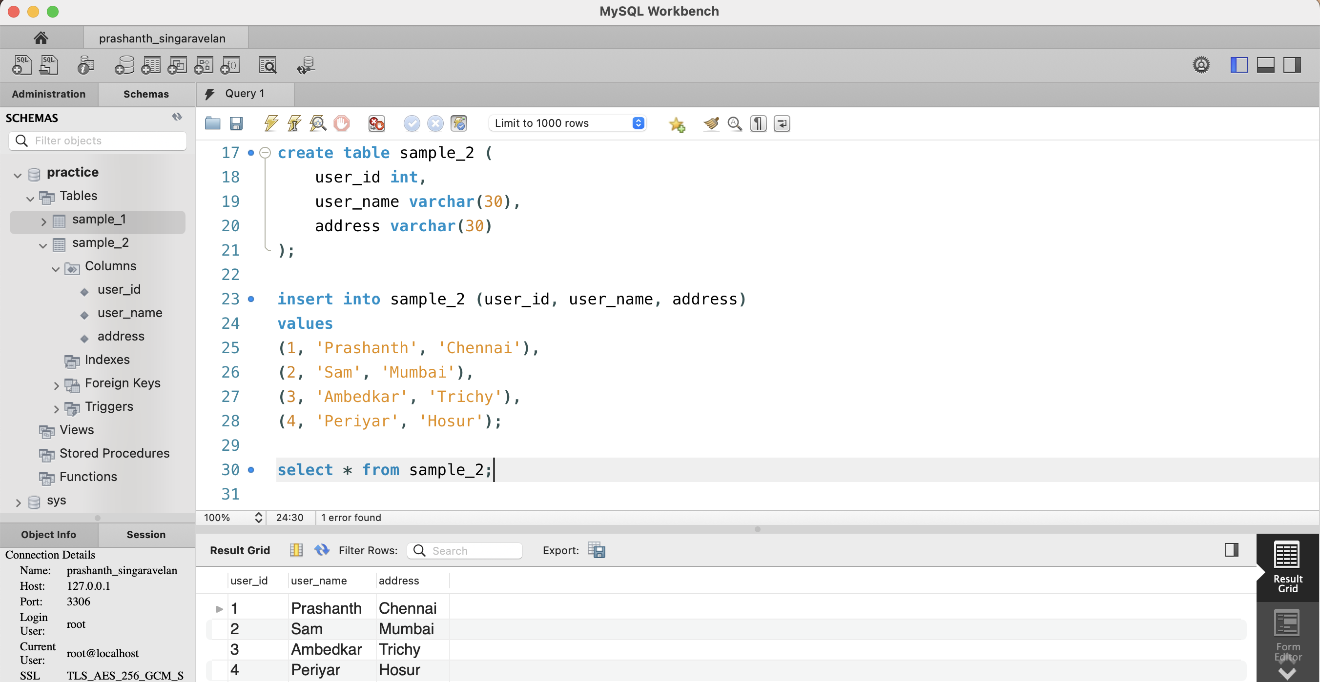

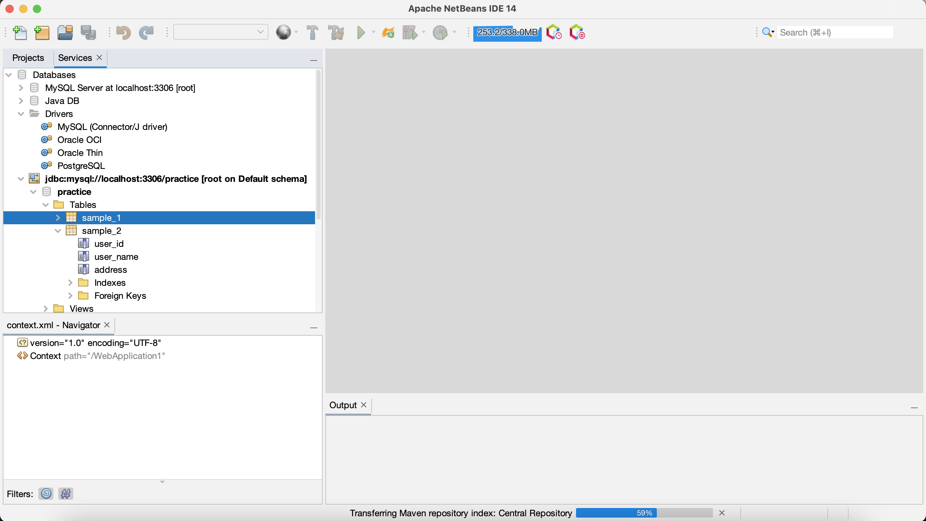

It is reflected back into Netbeans. So the connector is working fine.

Since we added practice data-base as the connector, the tables which are created under practice data-base are reflected here.

# **Step-2**

Add the connector to the Project

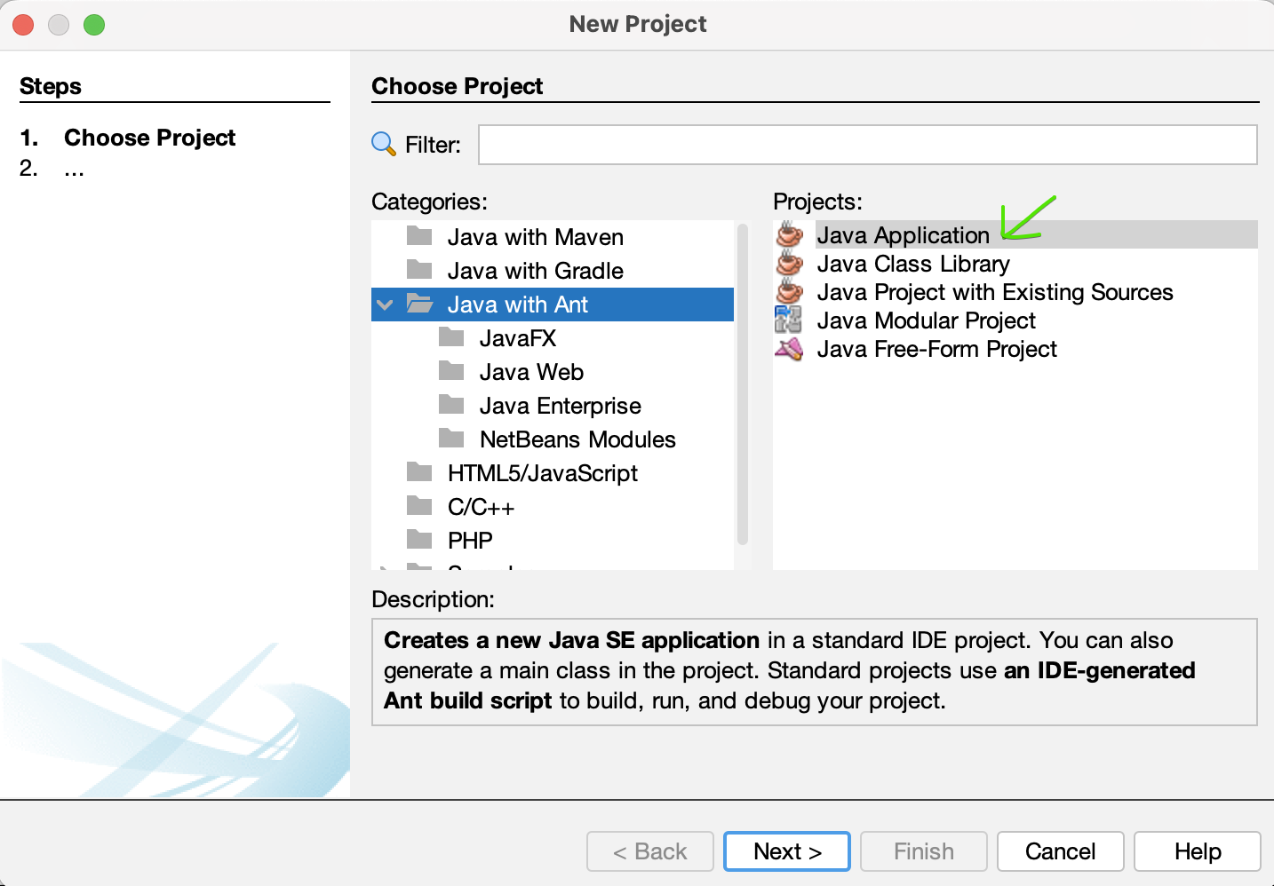

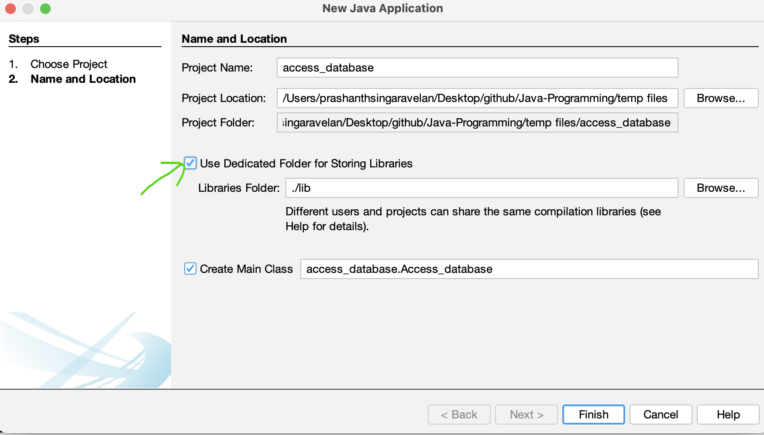

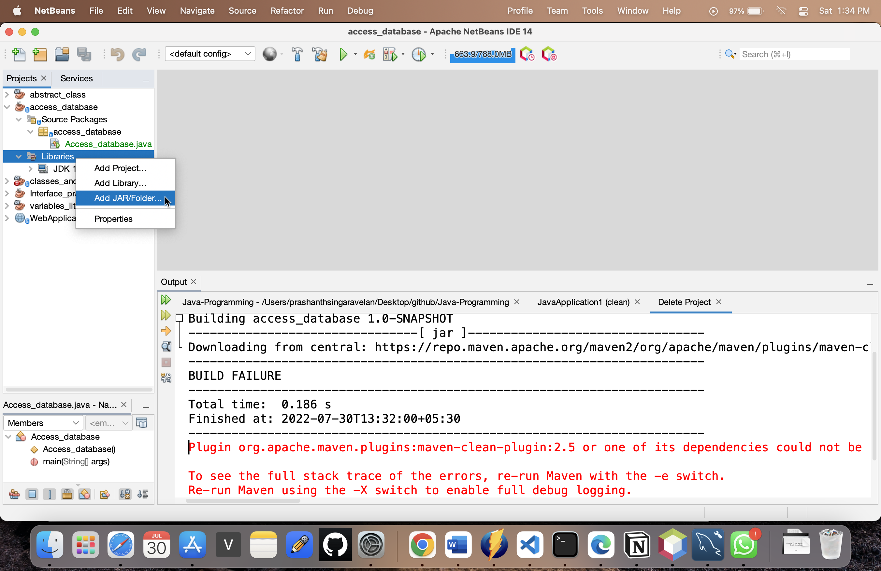

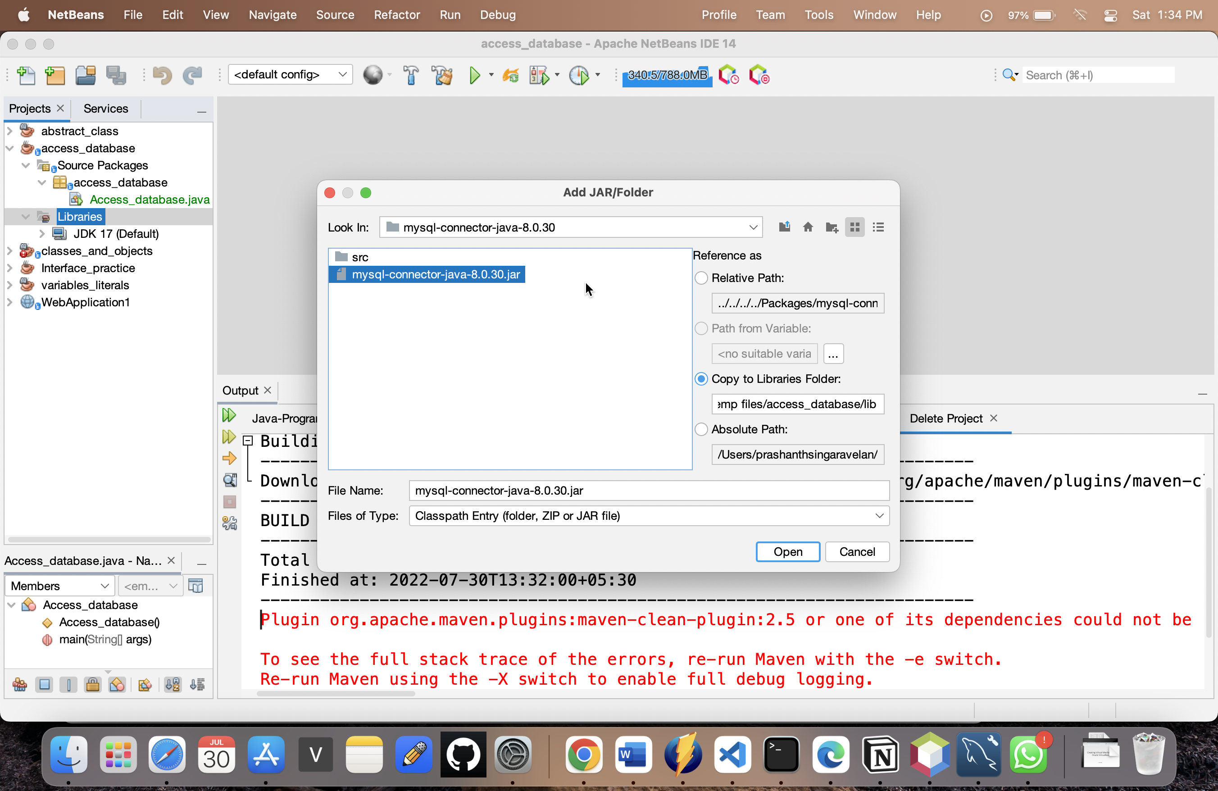

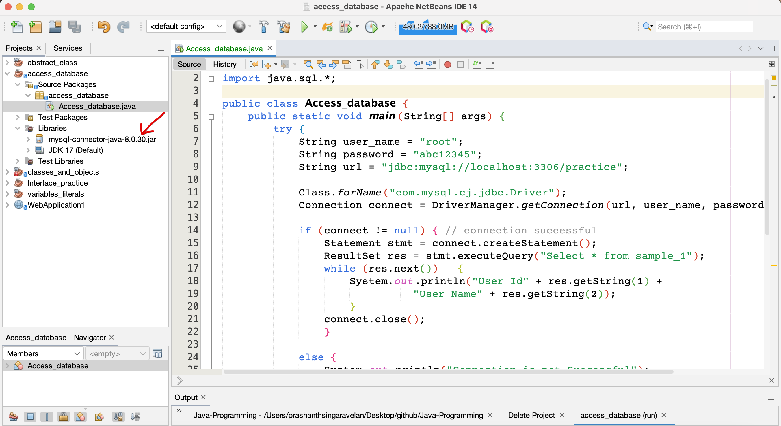

# **Start the Tomcat Server**

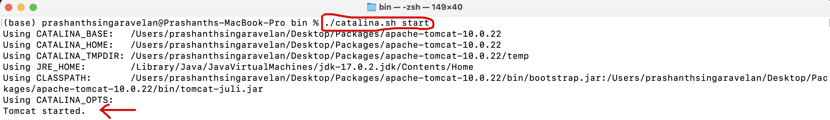  
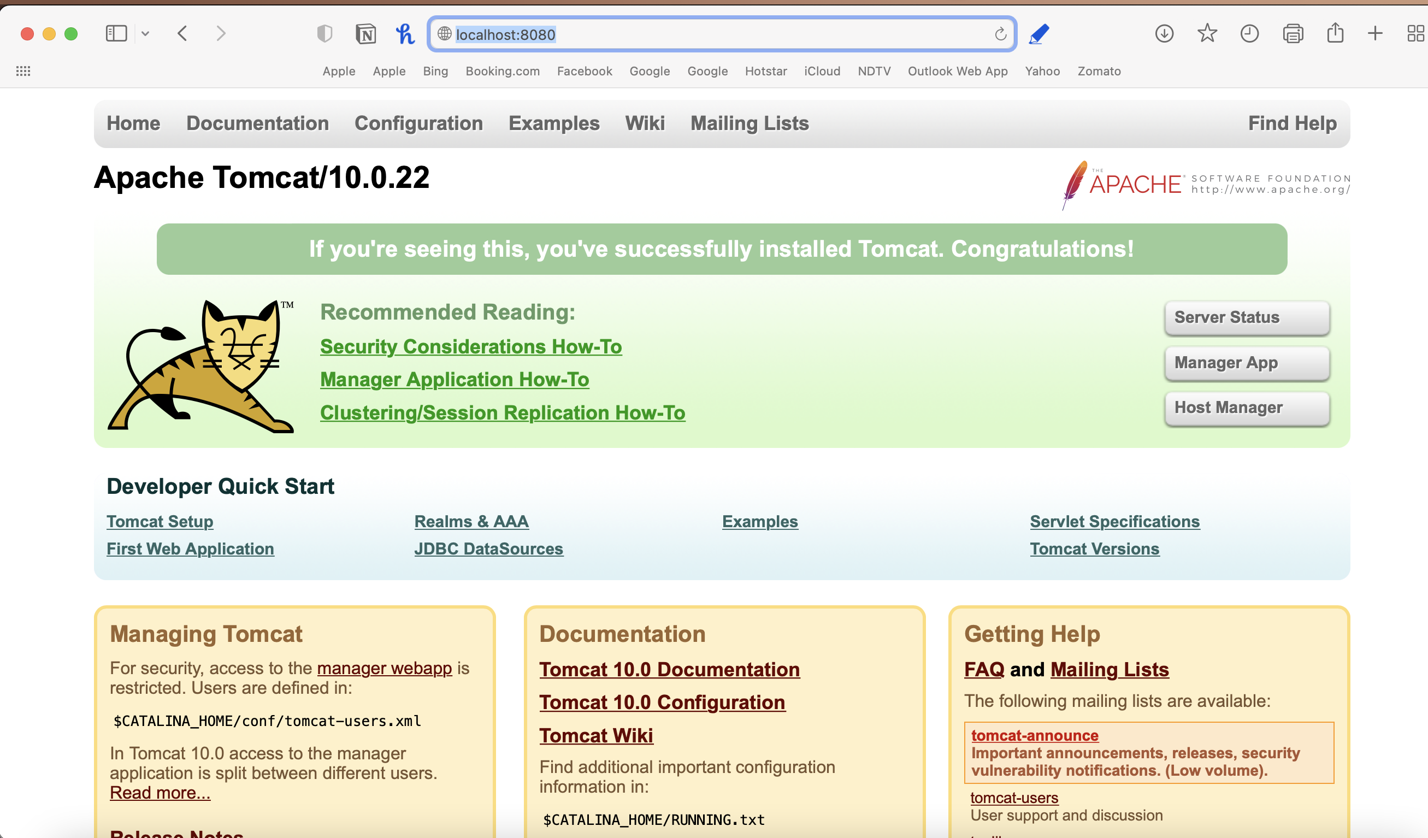

**Stop the Tomcat Server**  
